How to configure your computer to work on the version-controlled documents for a CD release.

These instructions only need to be done once. After that, refer to the section How to work with documents under version control below.

1) If you don’t already have a TortoiseSVN client, download and install the latest from http://tortoisesvn.tigris.org/download.html

2) Create a directory on your local machine, where you would like to keep local copies of the documents. By way of example, we’ll assume you will be using C:\CD release\Documents.

3) In Windows Explorer, right click on the new folder and select SVN Checkout:

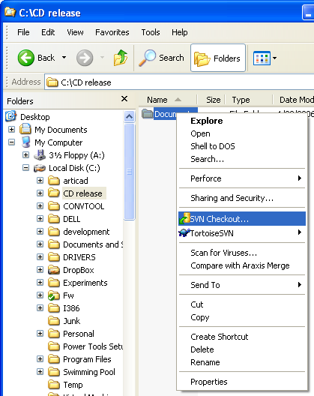

4) For the URL of repository, use svn://LS-CDBuilder.dallas.sil.org/Products/Documents:

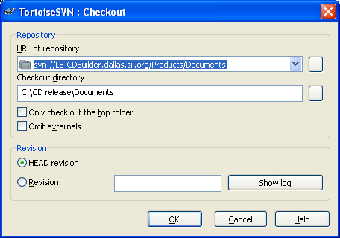

If you know which specific document folder you need, you can extend the URL to be more specific. For example, if you only want FieldWorks documents, use svn://LS-CDBuilder.dallas.sil.org/Products/Documents/FieldWorks.
Click on OK. You may then be asked for your username and password. You might like to check the box to save these, so you don’t have to enter them every time you contact the server.

5) All the latest documents will be downloaded onto your machine. This could take a few minutes. At the end, you should get something like this:
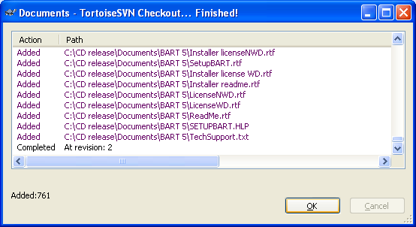

How to work with documents under version control.

1) The first thing to do is to make sure you are starting with up-to-date documents. In Windows Explorer, right click on the folder where you keep the documents, and select SVN Update:

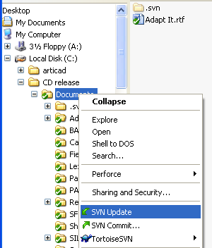

The latest documents should be downloaded to your computer.

2) You are now free to edit any that you need to.

3) When you have finished editing, you need to send the documents back to the server. To do that, right click on the Documents folder and select SVN Commit:

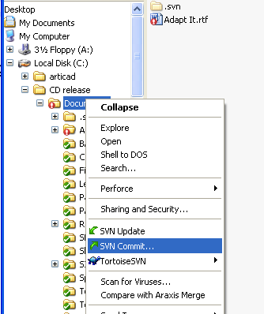

You will then get a dialog box something like this:

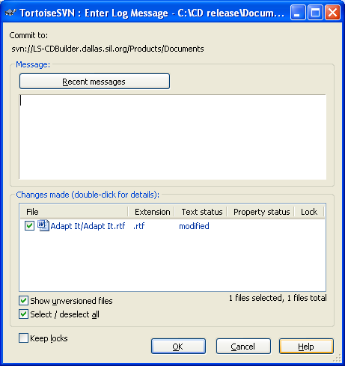

The upper edit pane is for you to type in a brief description of the changes you have made. The list in the lower pane identifies all the documents you have changed. It is a good idea to review this list and make sure it agrees with what you think you have changed. Uncheck any documents you are not finished with.
Click OK to send the documents to the server.
You are now done!

